Understanding Accounting Software

The main term of accounting software are ASSET,INCOME,LIABILITY,EXPENSE .All Transaction process depends on these term. This term are called NON-POSTED term. NON-POSTED term means, never transaction in this term but all transaction process depends on its.

Another main key of accounting are DEBIT and Credit. These are accounting entry term. Debit and Credit measure of increase and decrease Asset, expense, Liability, Owner’s Equity etc.

In Accounting, basically three types of account.

1. Debit Account 2.Credit Account 3.Journal Account

Behave of ASSET, INCOME, LIABILITY, and EXPENSE:

Behave

Income

Liability

Expense

Asset

Credit

Debit

Transaction Area:

Non-Posted

Posted

Asset:45,000

AC=2 Pic=14,400

Table:5 Pic=600

Current Asset: 10,000

Cash/Bank: 20,000

Fixed Asset:

Example: Debit and Credit

----When a company sales a PC, Company Income is increase, also increase company Asset. Here Income=Credit and Asset=Debit.

---- When a company buy a PC, Company Expense is increase, also increase company Asset. Here Expense = Debit and Asset=Credit.

Money receipt is all-time debit type and Payment is all-time Credit type.

Journal type is Totally Non-backing Transaction.

Contra type is back to back Transaction.

Credit:

GIRL

G=Gain

I=Income

R=Revenue

L=Liability

Debit:

DEAL

D=Dividend

E=Expense

A=Asset

L=Losses

Accounting Software Documentation:

Create New Company Project: (UI_Gateway/CompanyList)

Description:

When Create New Company Project Super Group /Primary Group “Income,Asset,Liability,Capital,Expenditure” Are Insert into tblConf_BalanceSheet Table

These terms are main in a accounting software.

Affect Table:

tblAC_cmp_Companys(Insert Company Info)

tblAC_cmp_Currencys(Inset Currency Info)

tblAC_grp_Group_Head(Insert Data From tblAC_grp_Group_Head_Model)

tblConf_BalanceSheet(Insert TopicName=Asset,liability,income,expenditure)

tblConf_Voucher(Insert Voucher=Receipt,Payment,Contra,Journal and

Type=credit/debit)

Picture:

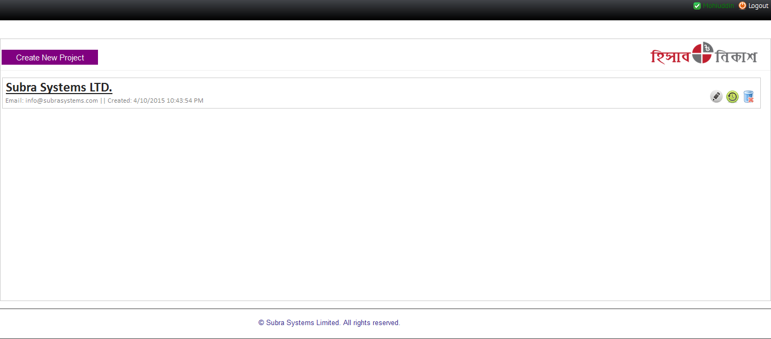

Home Page:( UI_Gateway/Index)

Description:

Show Company income Statement (Monthly, Yearly) in chart

Affect Table:

tblAC_leg_LedgersTransaction(Select Data For Show Chart)

Picture:

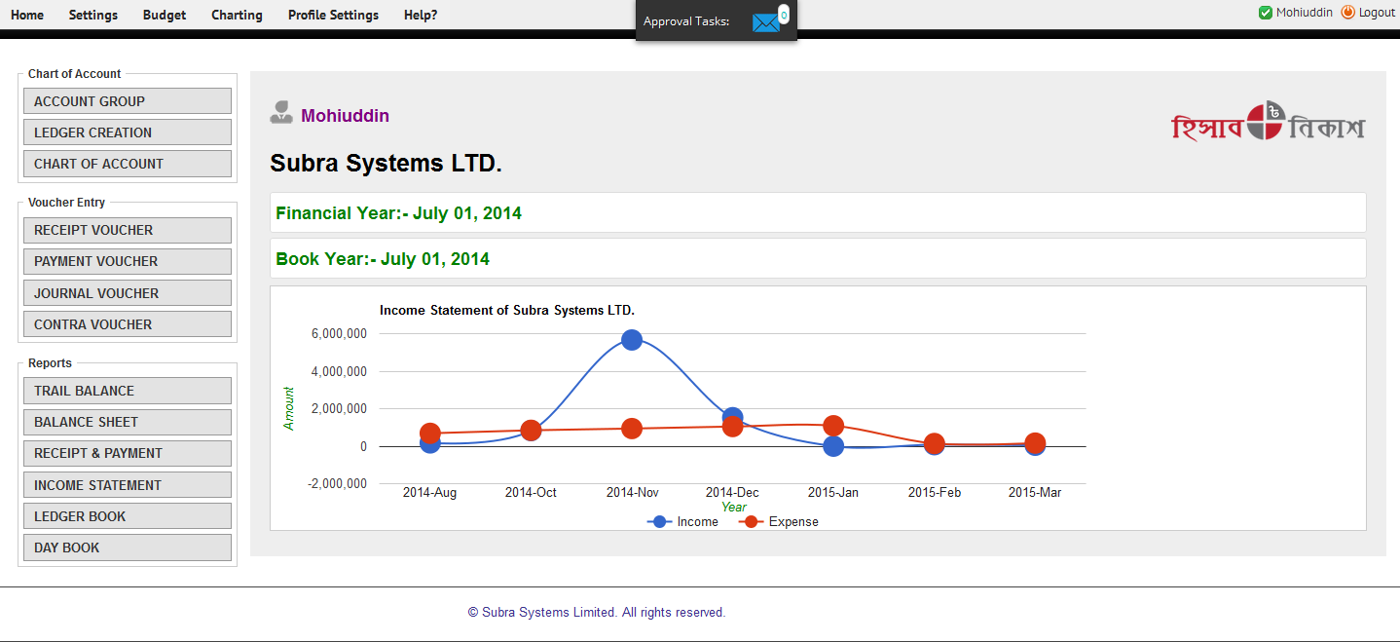

Accounting Group:( UI_Account/AccountGroup)

Description:

Create New Group As a Primary or Under Any Group. Can Print Report group details (primary and Under Groups) and also can insert, update data.

Affect Table:

tblAC_grp_Group_Head(For Data Show in grid view and rdlc reports)

Picture:

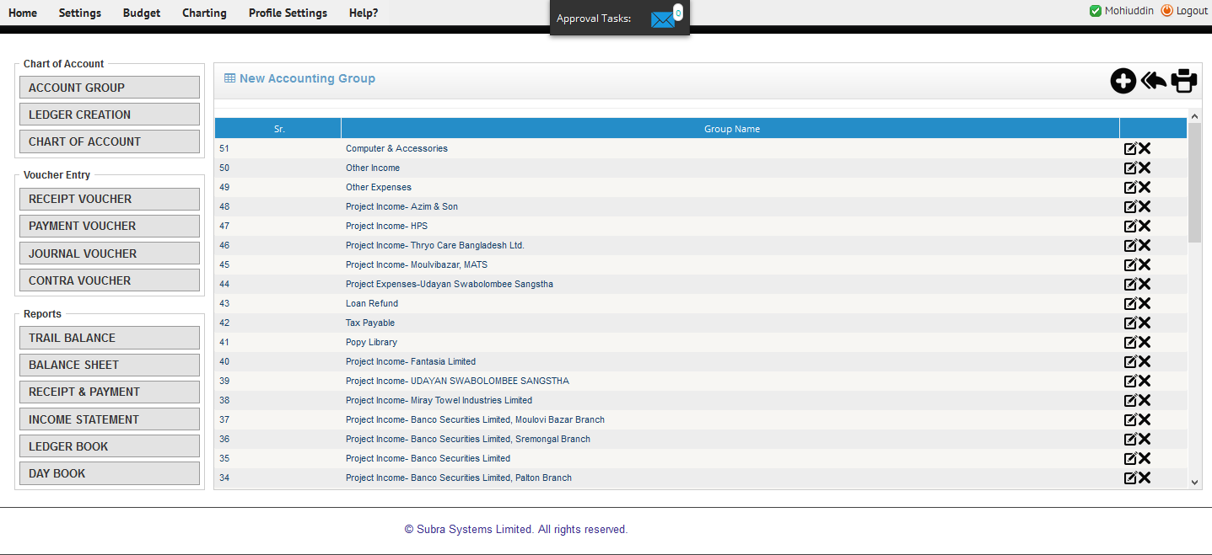

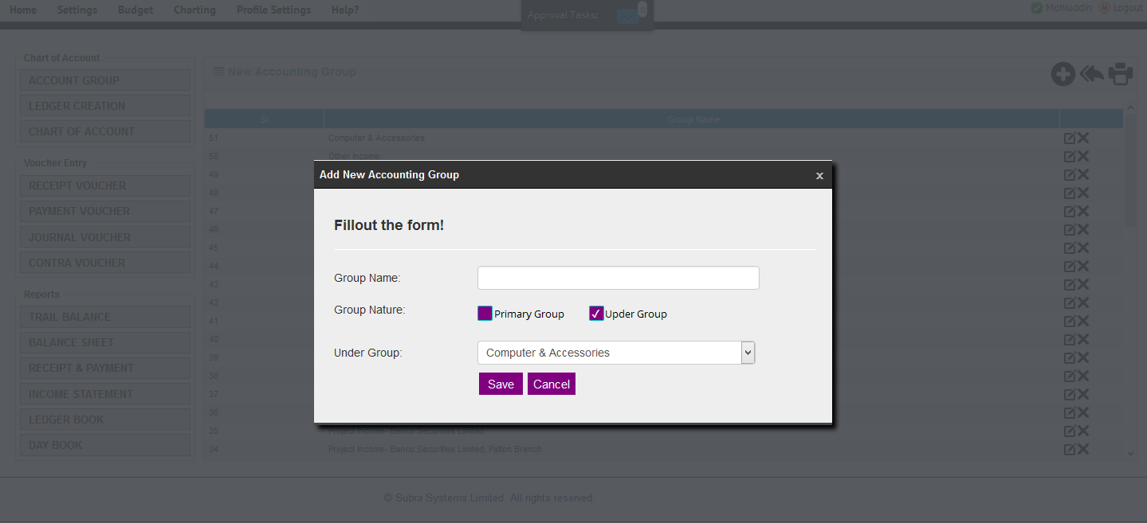

Ledger Creation (UI_Account/AccountLedger)

Description:

Create Ledger. Select Group Name and Ledger Number (Auto Generate) and Input Opening Balance (If have any pervious Balance Input This or Default value 0.00).Nature Type (Credit/Debit) Auto selected From Group Name.

Can Search, Delete, Update and Print reports

Affect Table:

tblAC_leg_Ledgers and tblAC_grp_Group_Head(Select Data for Show and Reports)

tblAC_cmp_Currencys(Select Data for Show)

tblAC_leg_Ledgers(Insert,Update,Delete Data)

tblAC_leg_Ledgers(Insert Data)

tblAC_leg_LedgersTransaction(Insert Data)

tblAC_leg_LedgersBalance(Insert Data)

Pictures:

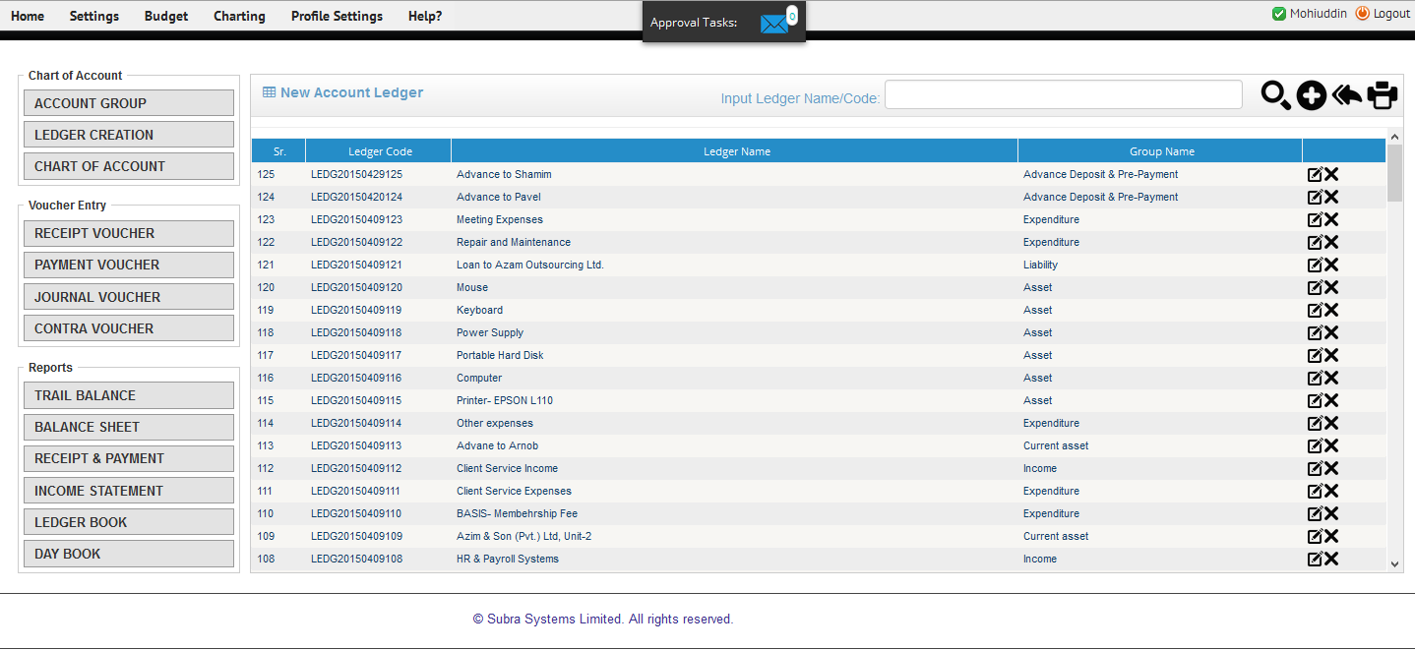

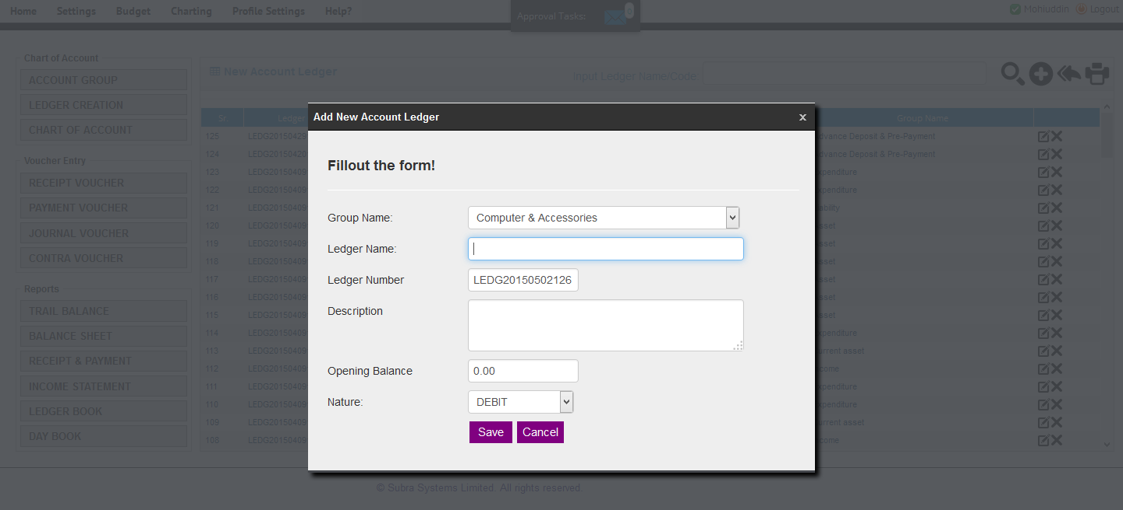

Chart Of Account: UI_Account/AccountLedger

Description:

Show Ledgers Details in Grid and can insert, update, Print report

Affect Table:

tblAC_leg_Ledgers(Show Data)

tblAC_grp_Group_Head, tblAC_leg_Ledgers(For reports)

Picture:

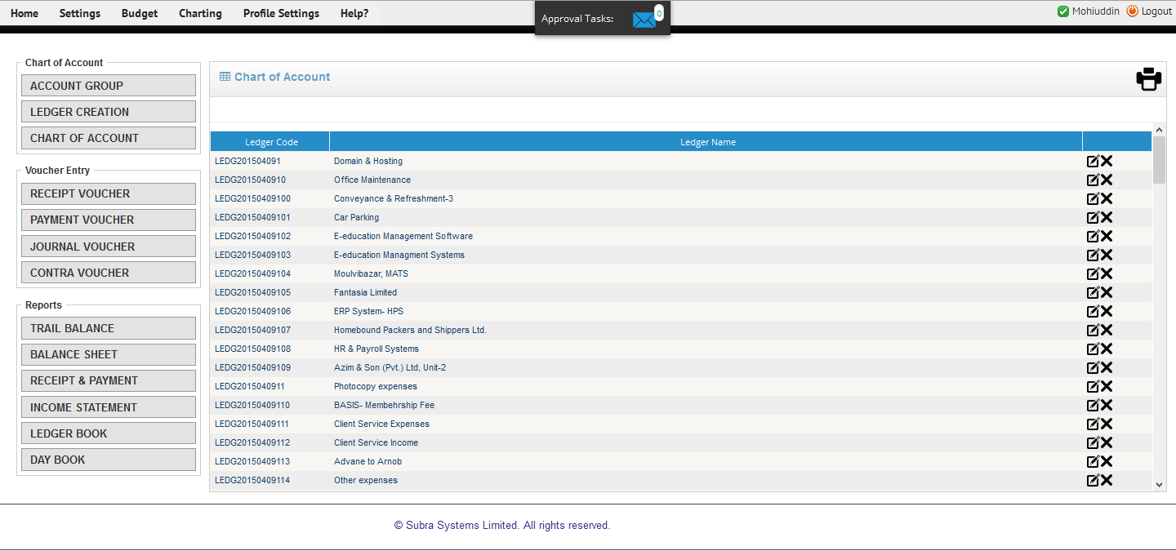

Receipt Voucher: UI_Voucher/ReceiptVoucher

Description:

Add Ledger. When add ledger select nature type (credit/debit).in receipt voucher cash/bank=debit and all non-bank=credit. Debit and credit basically double entry process. First time all ledgers are insert a temp table than when finally save all ledgers are main table and temp table data are delete and status are pending. Than need approve ledgers. When click approve button (redirect=ledgers List page).

In approve, select ledgers and approve. Show all ledgers, Can search ledgers multiple away.

**debit=credit all time equal**

Can Ledgers Discard.

Affect Tables:

Insert Data:

tblAC_vch-Voucher_Master_temp

tblAC_vch_Voucher_log

Approve:

tblAC_vch_Voucher_Master(Insert Data From tblAC_vch-Voucher_Master_temp)

tblAC_vch_Vouche_log(Update:Status=”APV”)

tblAC_leg_ledgersBalance(Update:Balance=”…..”)

tblAC_vch_Voucher_details(Insert Data)

tblAC_leg_ledgersTransaction(Insert Data)

tblAC_Leg_LedgersTransaction_Temp(Delete Data)

Discard:

tblAC_leg_ledgersTransaction_Discarsd(Insert Data)

tblAC_leg_ledgersTransaction_Temp(delete data)

tblAC_vch_Voucher_Master_Temp(delete data)

tblAC_vch_Vouche_log(delete data)

Pictures:

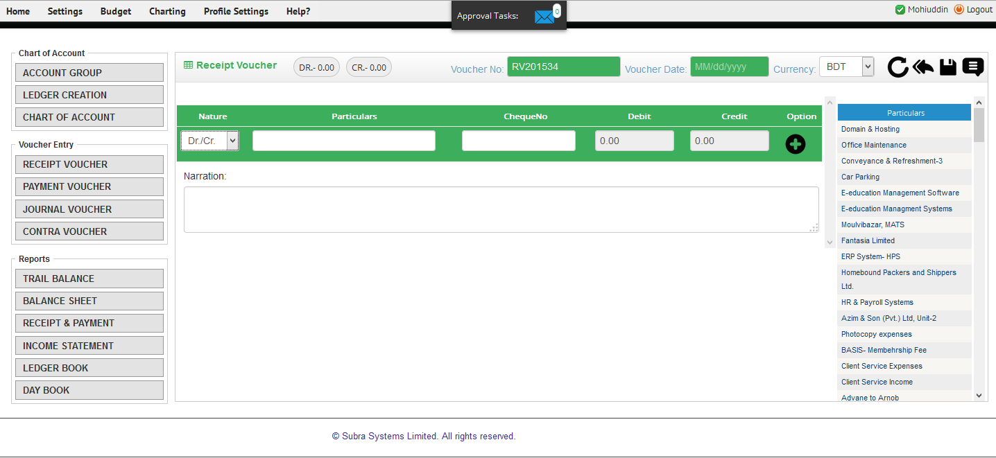

Payment Voucher: UI_Voucher/PaymentVoucher

Description:

Add Ledger. Select nature type (credit/debit).In receipt voucher cash/bank=credit and all non-bank=debit. Debit and Credit basically double entry process. First time all ledgers are insert a temp table than when finally save all ledgers are main table and temp table data are delete and status are pending. Then need to approve ledgers. When click approve button (redirect=ledgers List page).

In approve, select ledgers and approve. Show all ledgers, Can search ledgers multiple away.

**debit=credit all time equal**

Can Ledgers Discard

Affect Tables:

Insert Data:

tblAC_vch-Voucher_Master_temp

tblAC_vch_Voucher_log

Approve:

tblAC_vch_Voucher_Master(Insert Data From tblAC_vch-Voucher_Master_temp)

tblAC_vch_Vouche_log(Update:Status=”APV”)

tblAC_leg_ledgersBalance(Update:Balance=”…..”)

tblAC_vch_Voucher_details(Insert Data)

tblAC_leg_ledgersTransaction(Insert Data)

tblAC_Leg_LedgersTransaction_Temp(Delete Data)

Discard:

tblAC_leg_ledgersTransaction_Discarsd(Insert Data)

tblAC_leg_ledgersTransaction_Temp(delete data)

tblAC_vch_Voucher_Master_Temp(delete data)

tblAC_vch_Vouche_log(delete data)

Picture:

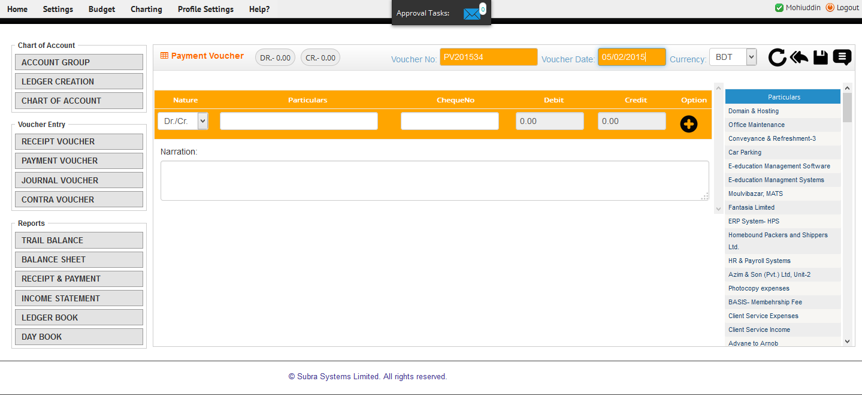

Journal Voucher: UI_Voucher/JournalVoucher

Description:

Add Ledger.select nature type (credit/debit).in receipt voucher

No Bank =credit and all non-bank=debit. Debit and credit basically double entry process. First time all ledgers are insert a temp table than when finally save all ledgers are main table and temp table data are delete and status are pending. Then need to approve ledgers. When click approve button (redirect=ledgers List page).

In approve, select ledgers and approve. Show all ledgers, Can search ledgers multiple away.

Can Ledgers Discard

**debit=credit all time equal**

Affect Tables:

Insert Data:

tblAC_vch-Voucher_Master_temp

tblAC_vch_Voucher_log

Approve:

tblAC_vch_Voucher_Master(Insert Data From tblAC_vch-Voucher_Master_temp)

tblAC_vch_Vouche_log(Update:Status=”APV”)

tblAC_leg_ledgersBalance(Update:Balance=”…..”)

tblAC_vch_Voucher_details(Insert Data)

tblAC_leg_ledgersTransaction(Insert Data)

tblAC_Leg_LedgersTransaction_Temp(Delete Data)

Discard:

tblAC_leg_ledgersTransaction_Discarsd(Insert Data)

tblAC_leg_ledgersTransaction_Temp(delete data)

tblAC_vch_Voucher_Master_Temp(delete data)

tblAC_vch_Vouche_log(delete data)

Picture:

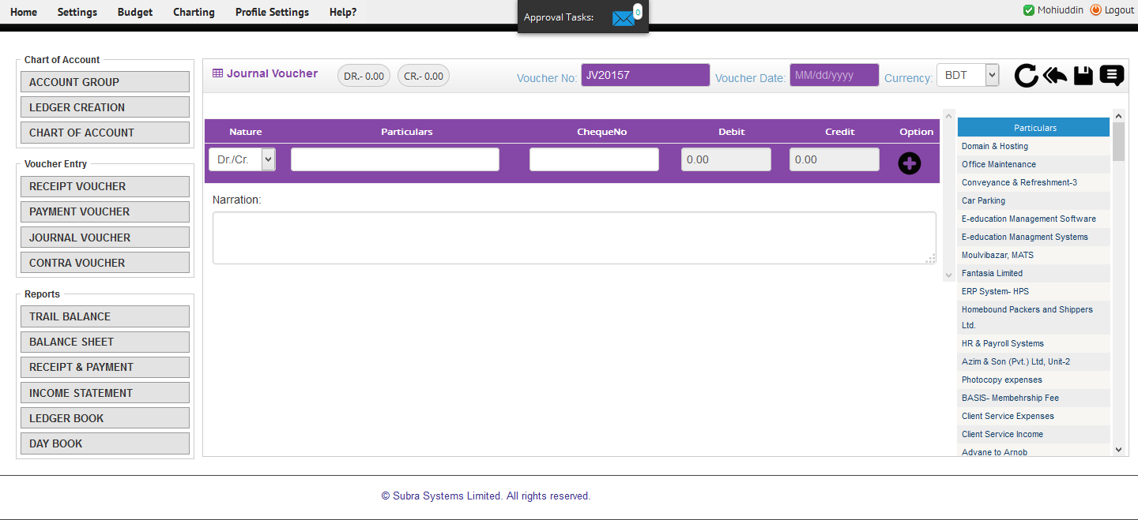

Contra Voucher: UI_Voucher/ContraVoucher

Description:

Add Ledger.select nature type (credit/debit).in receipt voucher

Bank =credit and all bank=debit. Debit and credit basically double entry process. First time all ledgers are insert a temp table than when finally save all ledgers are main table and temp table data are delete and status are pending. Then need to approve ledgers. When click approve button (redirect=ledgers List page).

In approve, select ledgers and approve. Show all ledgers, Can search ledgers multiple away.

Can Ledgers Discard

**debit=credit all time equal**

Affect Tables:

Insert Data:

tblAC_vch-Voucher_Master_temp

tblAC_vch_Voucher_log

Approve:

tblAC_vch_Voucher_Master(Insert Data From tblAC_vch-Voucher_Master_temp)

tblAC_vch_Vouche_log(Update:Status=”APV”)

tblAC_leg_ledgersBalance(Update:Balance=”…..”)

tblAC_vch_Voucher_details(Insert Data)

tblAC_leg_ledgersTransaction(Insert Data)

tblAC_Leg_LedgersTransaction_Temp(Delete Data)

Discard:

tblAC_leg_ledgersTransaction_Discarsd(Insert Data)

tblAC_leg_ledgersTransaction_Temp(delete data)

tblAC_vch_Voucher_Master_Temp(delete data)

tblAC_vch_Vouche_log(delete data)

Picture:

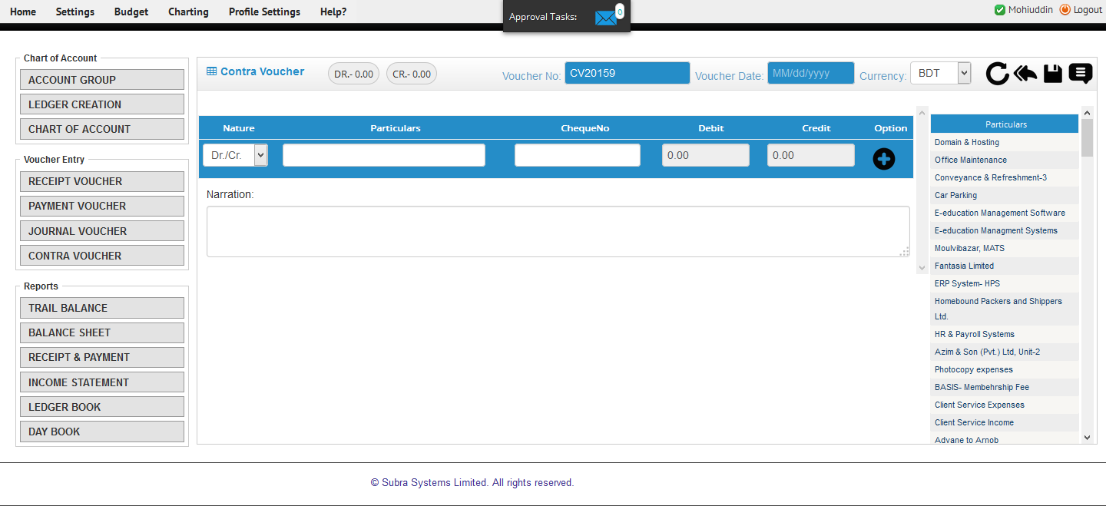

Trial Balance (Reports)

Trial Balance is a list of closing balances of ledger accounts on a certain date and is the first step towards the preparation of financial statements. It is usually prepared at the end of an accounting period to assist in the drafting of financial statements.

The trial balance is a report run at the end of an accounting period, listing the ending balance in each account.

Income statement (Reports)

Income statement is a company financial statement. The income statement is also referred to as the profit and loss statement, P&L, statement of income, and the statement of operations. The income statement reports the revenues, gains, expenses, losses, net income and other totals for the period of time shown in the heading of the statement.

Balance Statement (Reports)

Income statement is a company financial statement…………………………………………………Pending